1

Adventure Game

- 3D World  
- An interactive story with the main character  
- Adventure   
- Chilling/Relaxing feelings  
- Nice and relaxing colors  
- Pleasant visuals   
- Solving puzzles and problems plays a key role in the gameplay  
- Requires mental effort from the player  
-  The game combines the characteristic features of quests and action genre

+deep forrest

+ Collector game

Specific theme  
visuals and music following it

Japanese Hack’n’Slay

+magic

2

You're pole dancer gone rogue in a Crime City nightlife setting

+retro futuristic world (60's nuclear tech n 🤬)

+chernobyl

+interesting and complex characters

+Ghost hunting

3

Octopus school

+dogs playing tennis

+volcano surfer

+Gravity doesn't work that way!

GDD – A warring State

* Setting: Japan, 1500-something (Time of civil war “Sengoku Jidai”)
* Core Gameplay: Stealth and Souls-like with using a card-deck for abilities.
* Top-Down round based strategy (similar to games like Desperados)
* Story-heavy, focused on the rising of Ieyasu Tokugawa (future Shogun (ruler) of Japan
* Meant to show the consequences of war for the people
  + E.g. Losing family members, homes destroyed
* Decision have to be made by:
  + Choosing equipment -> every equipment has pros and cons (e.g. More armor but less movement)
  + Choosing cards for deck -> every ability has pros and cons (e.g. go invisible but cant attack
* Levels are round based (consisting of planning actions with character and executing them), redraw cards after each round
* Action-points per round (like in Divinity Original Sin)
* Unlock new cards depending on the chosen card mix in deck

External Goals:

* Creating a portfolio piece
* Creating a interesting mix of strategy and souls-like elements
* Advance level- & game-design knowledge
* Getting familiar with UE4

Internal Goals:

* Player creates a character that is adjusted to personal interests (e.g. fighting style)
* Motivate user to use different strategies for different levels
* Give the player a feeling of control (equipping cards and items) while not making the level “predictable” (through the random factor of drawing the cards)
* Player has to find a delicate balance between offensive and defensive abilities

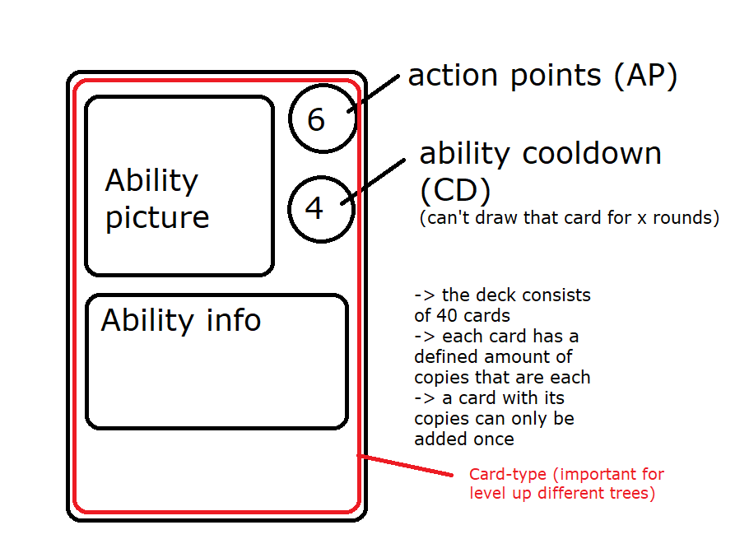Inspired by:

* Divinity Original sin I/II

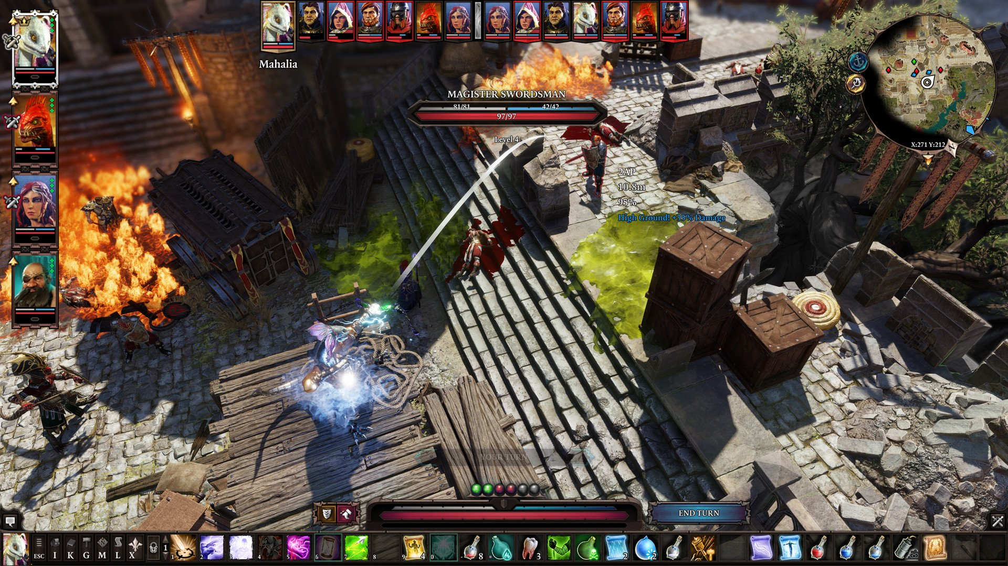

* Desperados (III)

